MINI PROJECT 2

HEALTHCARE ANALYTICS USING SQL SERVER,

POWER BI AND TABLEAU

AIM
To create a healthcare analytics system using SQL Server, Power BI, and Tableau to store, analyze, and visualize patient and hospital admission data and derive meaningful healthcare insights.

Domain and Problem Statement

Domain
Healthcare Analytics

Problem Statement
Healthcare organizations generate large amounts of patient and admission data. Analyzing this data manually makes it difficult to identify admission trends, common diseases, department performance, treatment costs, and patient demographics.
The proposed system uses SQL Server, Power BI, and Tableau to analyze healthcare data and present it through interactive dashboards. This helps users understand important healthcare patterns and make better data-driven decisions.

Dataset Description
The HealthcareDB database contains four related tables:

Patients
Contains details about patients.
Attribute | Description
Patient_ID | Unique patient identification number
Patient_Name | Name of the patient
Age | Age of the patient
Gender | Gender of the patient
City | Patient's city

Departments
Contains hospital department information.
Attribute | Description
Department_ID | Unique department ID
Department_Name | Name of the hospital department

Doctors
Contains doctor information.
Attribute | Description
Doctor_ID | Unique doctor ID
Doctor_Name | Name of the doctor
Department_ID | Department associated with the doctor
Experience_Years | Years of experience

Admissions
Contains patient admission and treatment information.
Attribute | Description
Admission_ID | Unique admission ID
Patient_ID | Patient identification number
Doctor_ID | Doctor identification number
Department_ID | Department identification number
Disease | Disease diagnosed
Admission_Date | Date of admission
Discharge_Date | Date of discharge
Treatment_Cost | Cost of treatment
Admission_Type | Type of admission
Patient_Status | Current/final patient status
The database contains 500 patients and 500 admission records, along with department and doctor information.

Data Source
The healthcare dataset was created and stored in Microsoft SQL Server.
Database: HealthcareDB
Database Management System: SQL Server 2025
The database was connected to:
- Microsoft Power BI Desktop for data preparation, modelling, DAX calculations, and dashboard creation.
- Tableau Desktop for visualization, calculated fields, parameters, and dashboard creation.

Data Preparation
The following data preparation steps were performed:
- Created the HealthcareDB database in SQL Server.
- Created four related tables:
  - Patients
  - Departments
  - Doctors
  - Admissions
- Defined primary keys for the tables.
- Defined foreign keys to establish relationships.
- Inserted healthcare records into the tables.
- Connected the SQL Server database to Power BI.
- Loaded the required tables into Power BI.
- Established relationships between the tables.
- Checked the data types of fields such as dates, numbers, and categorical values.
- Created an Age Group calculated column for demographic analysis.
- Created a Length of Stay calculated column using admission and discharge dates.
- Connected the same database to Tableau and established the required relationships.

Visualizations Used

Power BI
The following visualizations were created:
- KPI Cards
  - Total Patients
  - Total Admissions
  - Total Treatment Cost
  - Average Treatment Cost
  - Average Length of Stay
- Line Chart
  - Monthly Admissions Trend
- Clustered Column Chart
  - Admissions by Department
  - Admissions by Age Group
  - Treatment Cost by Department
  - Patient Status Analysis
- Bar Chart
  - Admissions by Disease
- Donut Chart
  - Gender Distribution
  - Admission Type Analysis
- Table
  - Patient Details
- Drill-through
  - Patient-level detailed analysis

Tableau
The following visualizations were created:
- Total Patients
- Total Admissions
- Monthly Admissions Trend
- Admissions by Department
- Admissions by Disease
- Gender Distribution
- Treatment Cost by Department
A Tableau calculated field and parameter were also created for interactive analysis.

Calculations Performed

Power BI DAX Calculations
Length of Stay
Length of Stay =
DATEDIFF(
Admissions[Admission_Date],
Admissions[Discharge_Date],
DAY
)
Total Patients
Total Patients =
DISTINCTCOUNT(Admissions[Patient_ID])
Total Admissions
Total Admissions =
COUNT(Admissions[Admission_ID])
Total Treatment Cost
Total Treatment Cost =
SUM(Admissions[Treatment_Cost])
Average Treatment Cost
Average Treatment Cost =
AVERAGE(Admissions[Treatment_Cost])
Average Length of Stay
Average Length of Stay =
AVERAGE(Admissions[Length of Stay])
Emergency Admissions
Emergency Admissions =
CALCULATE(
[Total Admissions],
Admissions[Admission_Type] = "Emergency"
)
Discharged Patients
Discharged Patients =
CALCULATE(
[Total Admissions],
Admissions[Patient_Status] = "Discharged"
)

Age Group Calculation
Patients were grouped into age categories such as:
- Under 20
- 20–29
- 30–39
- 40–49
- 50–59
- 60–69
- 70+

Tableau Calculation
Average Treatment Cost
AVG([Treatment_Cost])
A Treatment Cost Threshold parameter was also created for interactive cost-based analysis.

Insights Obtained
The dashboards provide the following important insights:
- The system contains 500 patients and 500 admissions, allowing overall healthcare activity to be monitored.
- The Monthly Admissions Trend helps identify variations in the number of admissions over time.
- Admissions by Department helps identify departments handling a higher number of patients.
- Admissions by Disease helps identify the diseases that occur more frequently within the dataset.
- Gender Distribution provides a comparison of male and female admissions.
- Age Group Analysis helps identify which age groups account for more hospital admissions.
- Treatment Cost by Department helps compare the overall treatment expenditure across departments.
- Average Length of Stay helps evaluate how long patients generally remain admitted.
- Admission Type Analysis helps compare different types of admissions, including emergency admissions.
- Patient Status Analysis provides an overview of patient outcomes/status.
- The Patient Details drill-through page allows detailed patient-level information to be examined.

SQL SERVER DATABASE CREATION

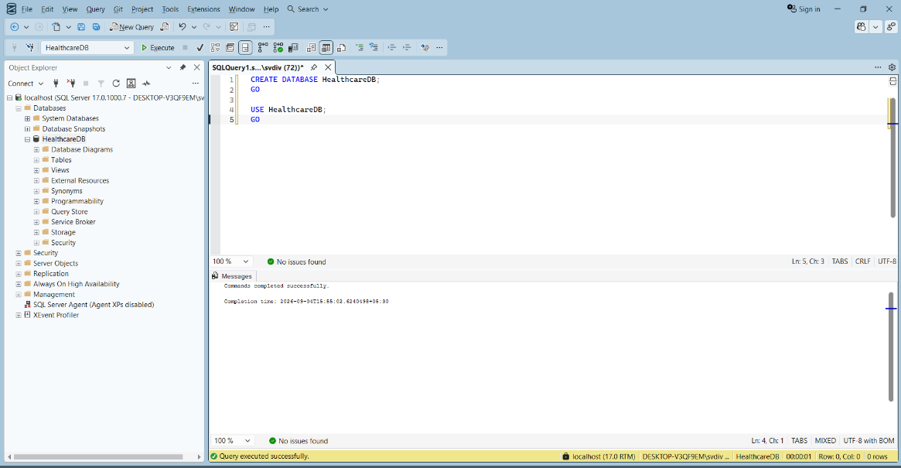

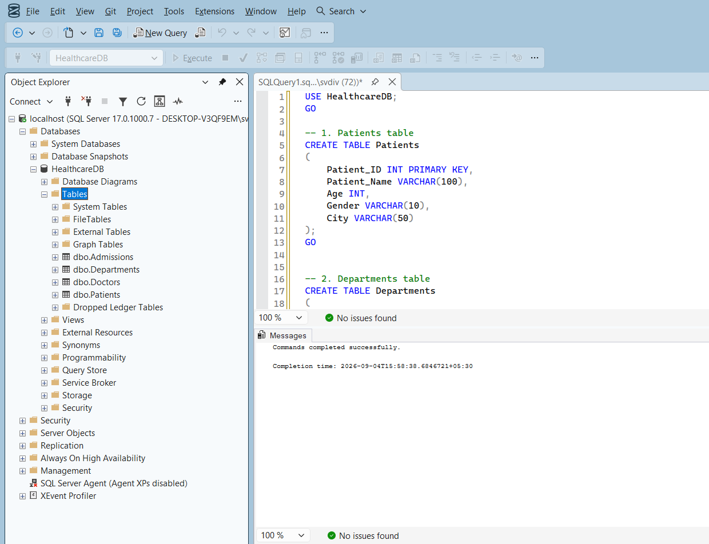

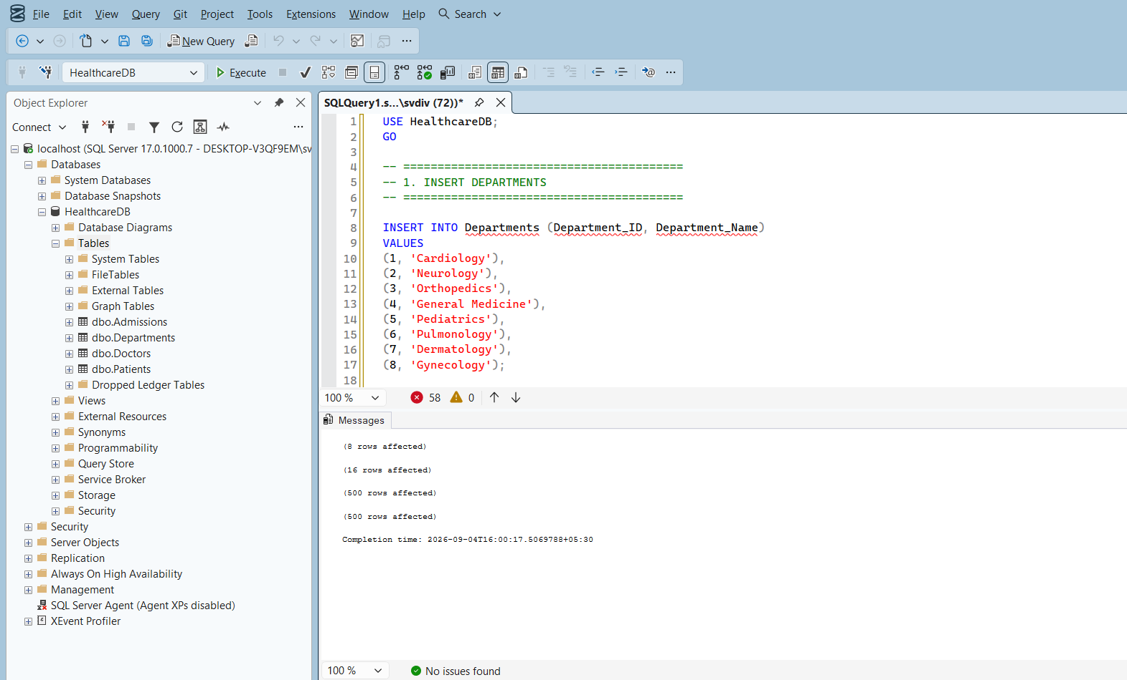

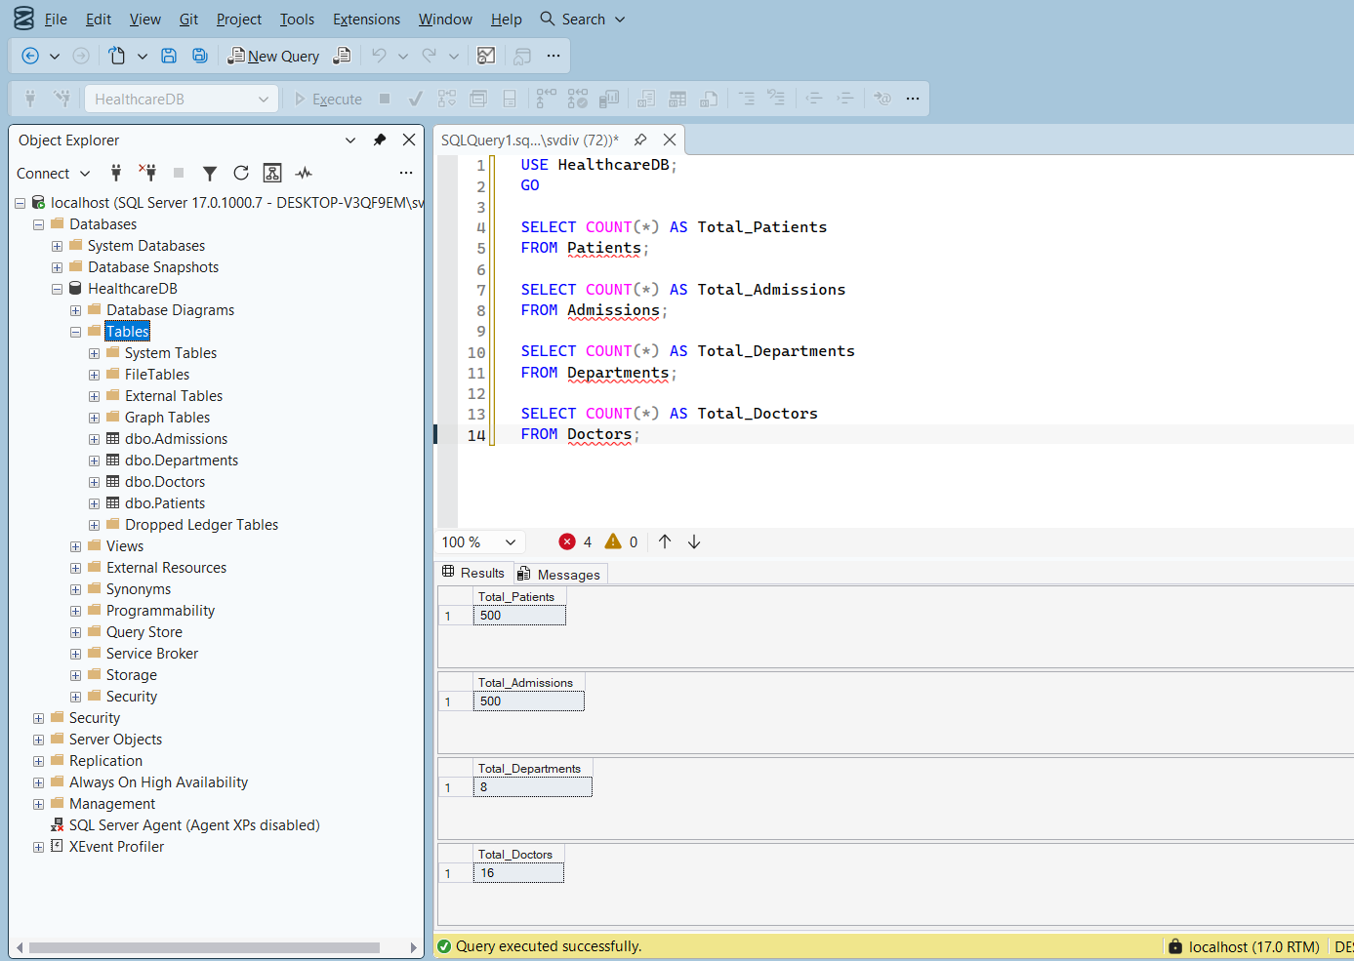

POWER BI DASHBOARD

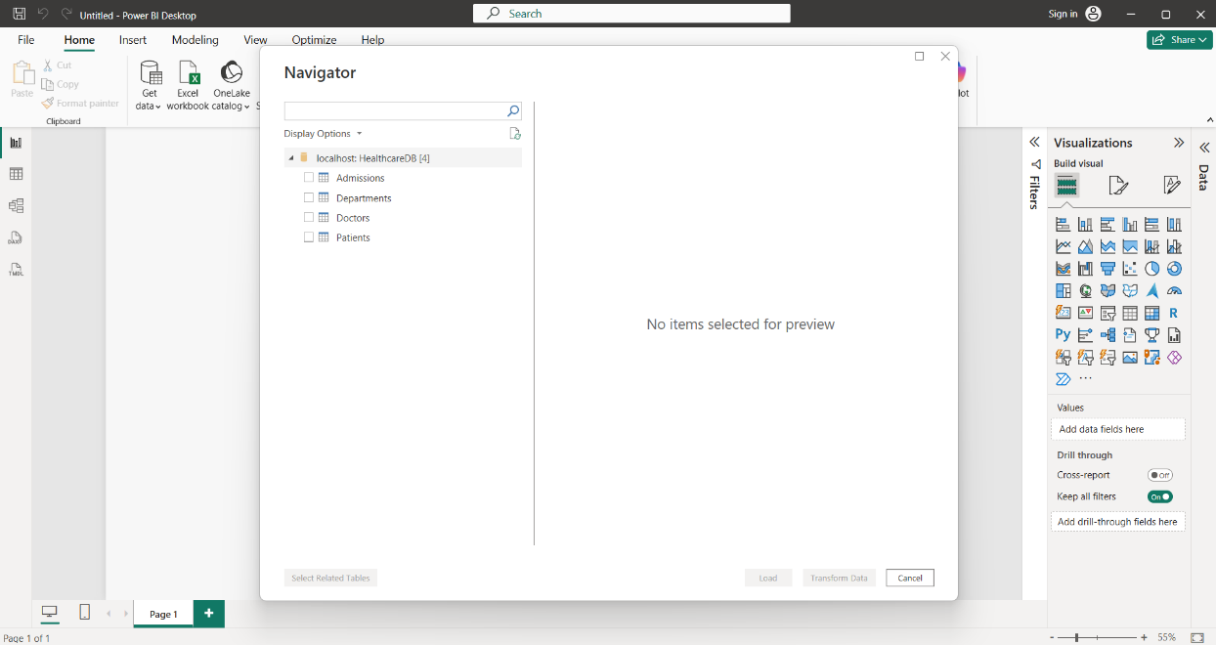
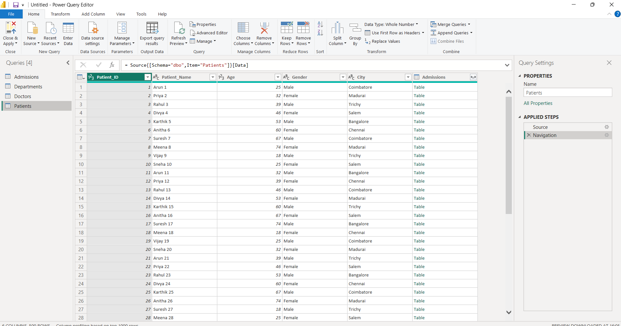
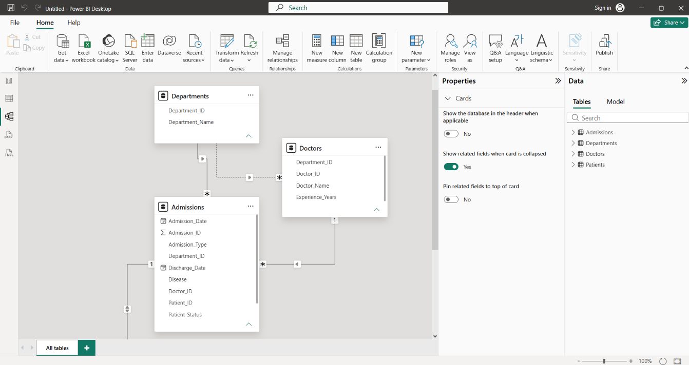

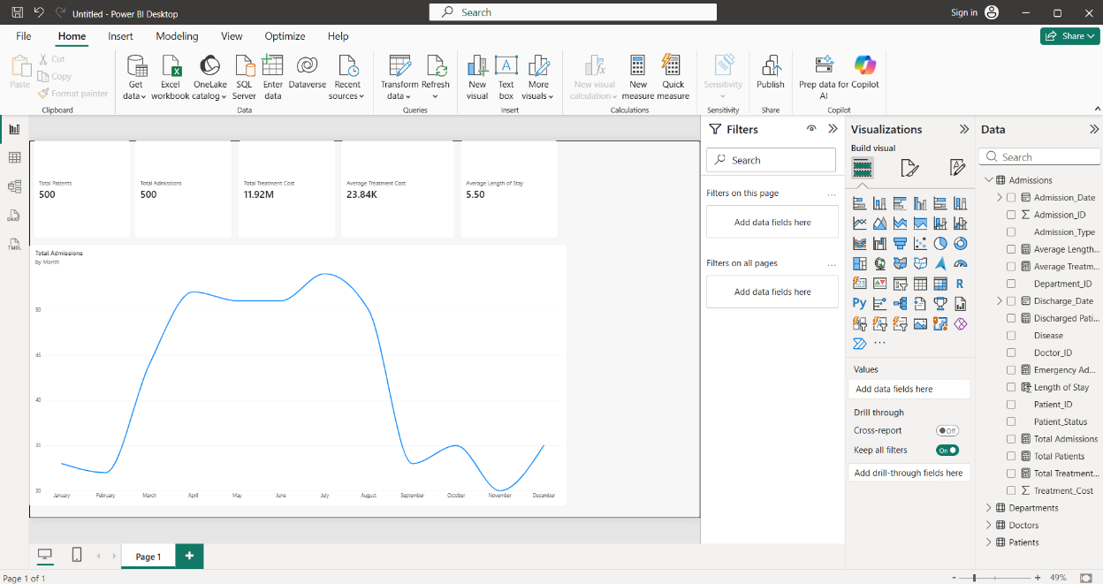

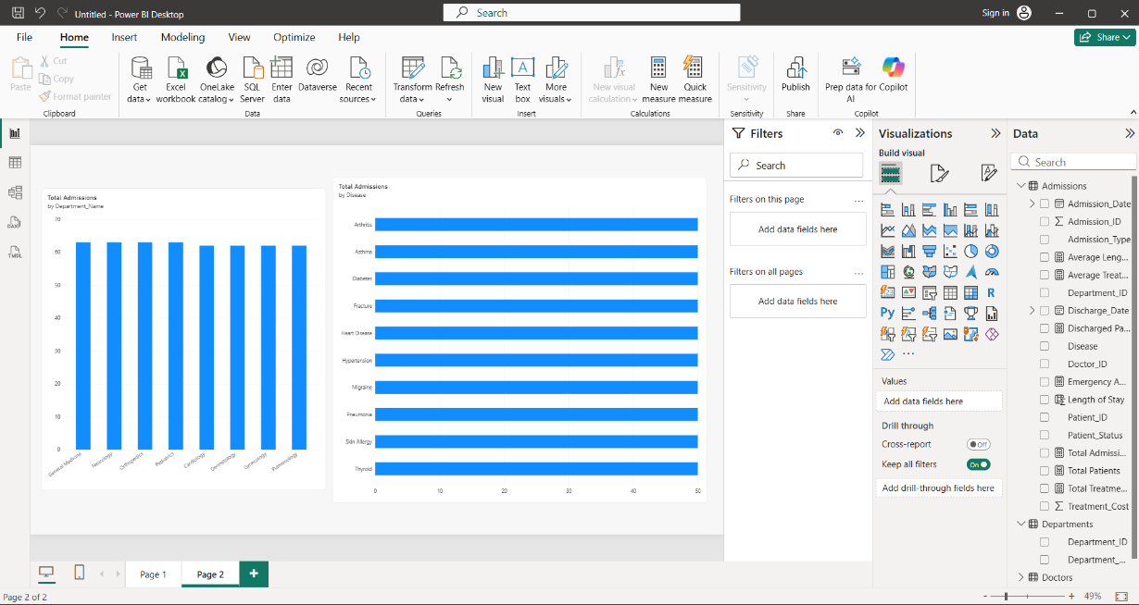

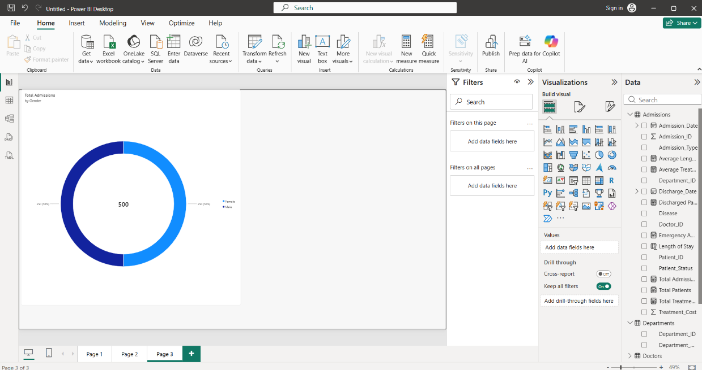

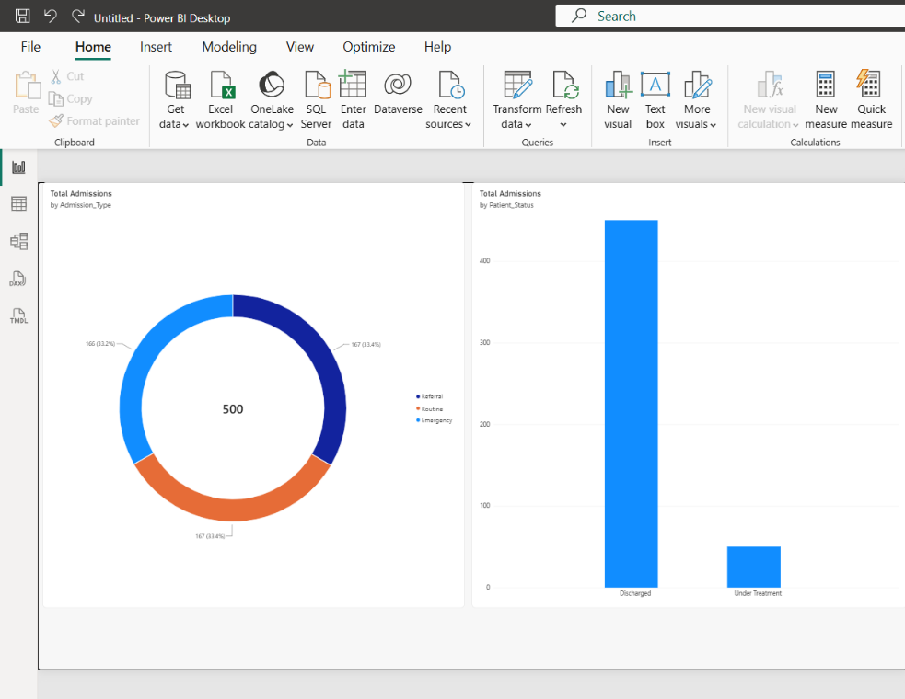

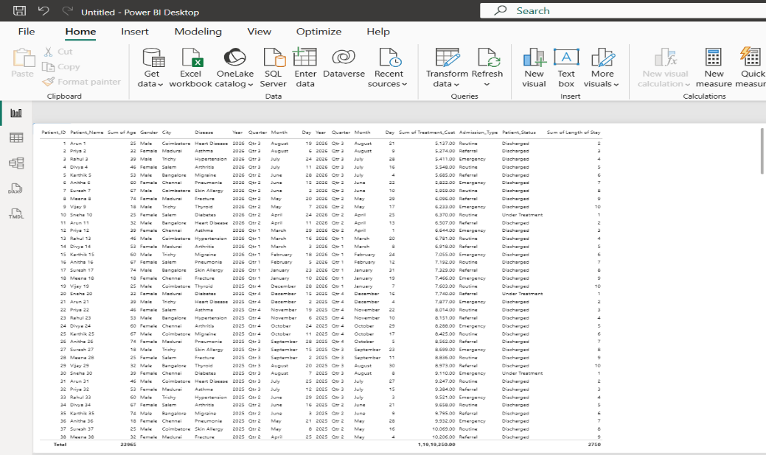

TABLEAU DASHBOARD

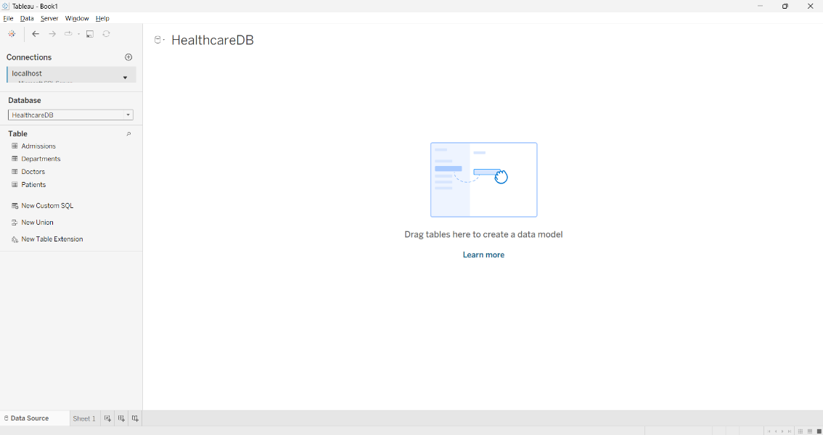

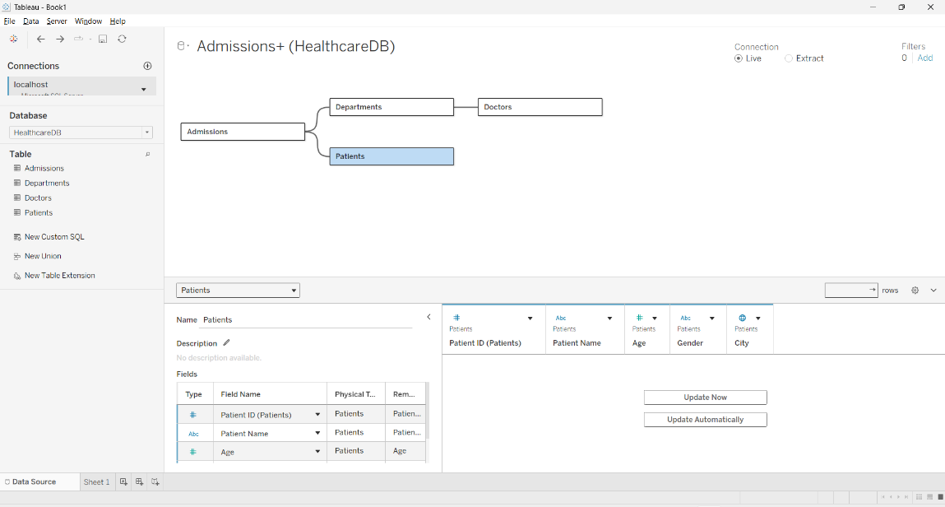

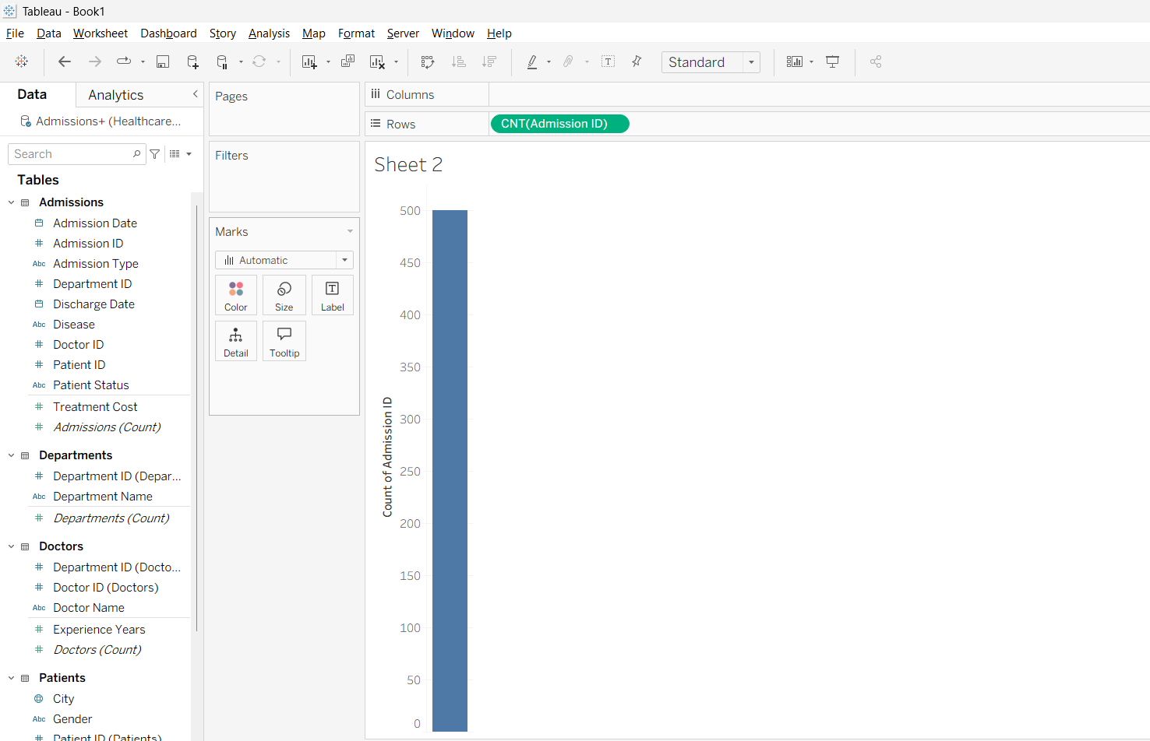

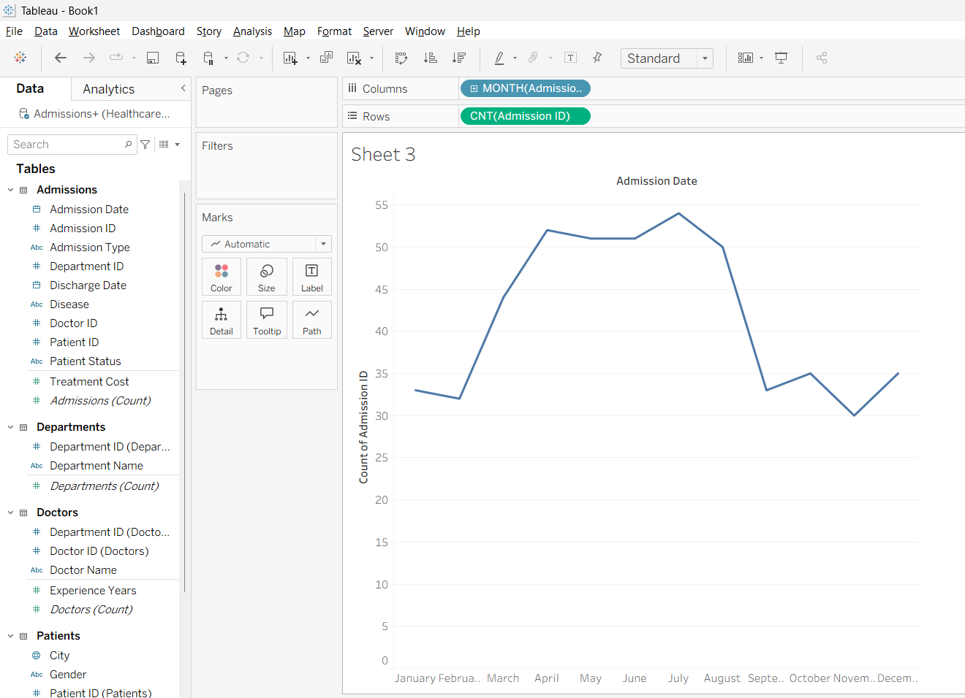

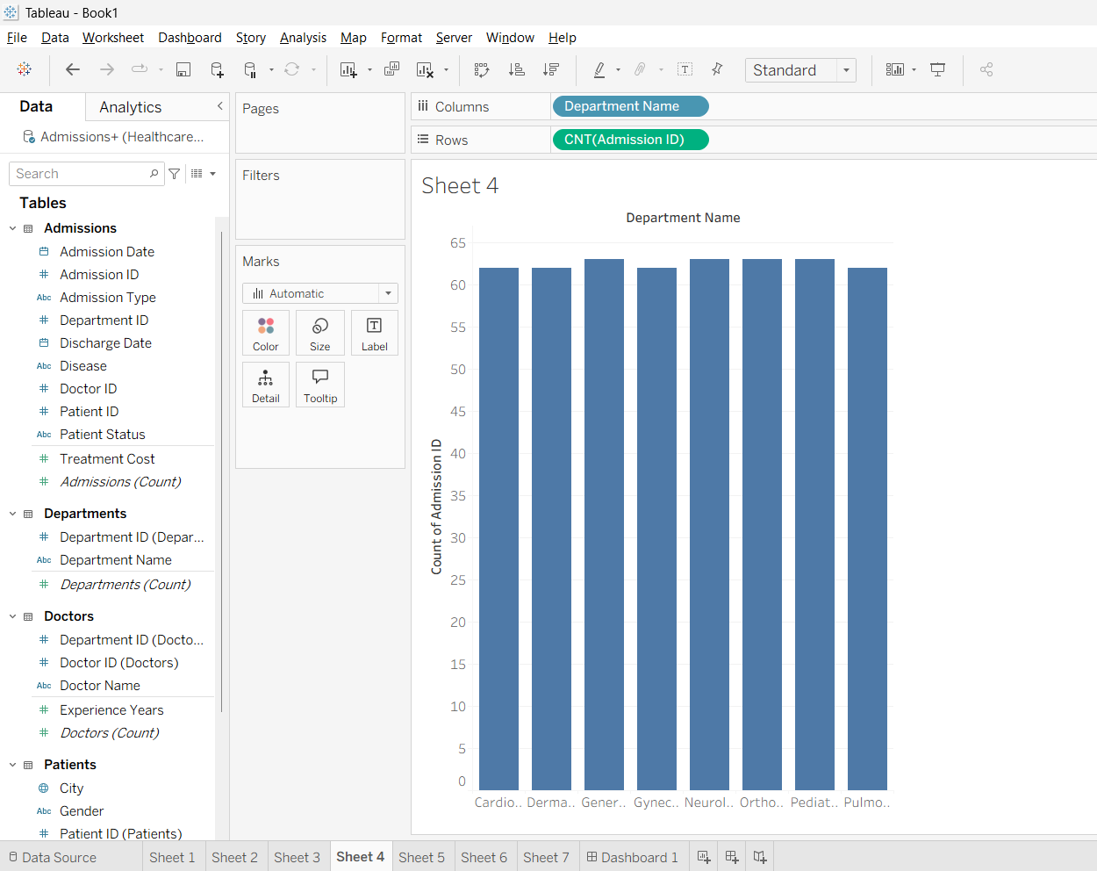

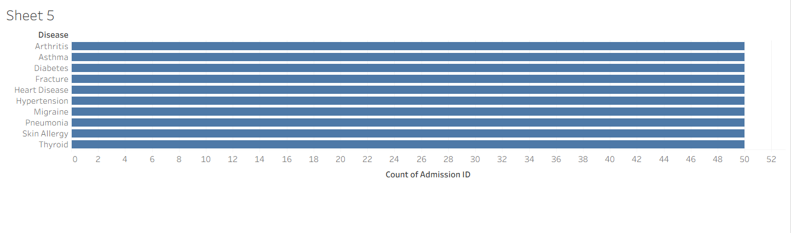

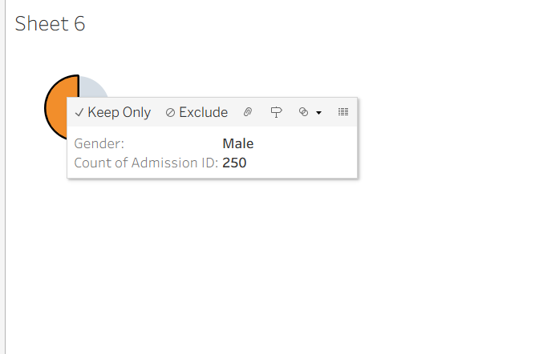

RESULT
Thus, the Healthcare Analytics Dashboard was successfully developed using SQL Server, Power BI, and Tableau. The system successfully stores healthcare data in a relational database and provides meaningful visual analysis of patients, admissions, diseases, departments, demographics, treatment costs, and hospital performance through interactive dashboards.

